Practical Week 2 -Task 1&2

Step 1: Open Ubuntu
Open Ubuntu from the Windows Start Menu.
You should see:
jhanasri@LAPTOP-1RN1M8E3:~$
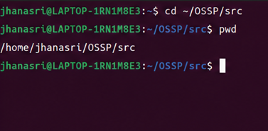

Step 2: Go to Your Project Folder
cd ~/OSSP/src
Check the current directory:
pwd
Expected output:
/home/jhanasri/OSSP/src
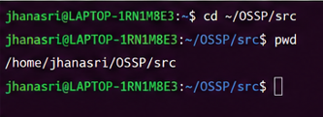

Step 3: View Existing Files
Ls
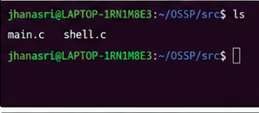

Step 4: Create a New C File
touch command_executor.c
Verify:
ls
You should see command_executor.c.
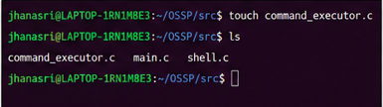

Step 5: Open the File
nano command_executor.c
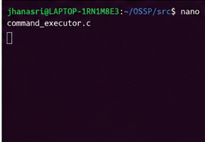

Step 6: Type/Paste the Program
#include <stdio.h>
#include <stdlib.h>
#include <unistd.h>
#include <sys/wait.h>

int main()
{
char command[100];

printf("Enter a Linux command: ");
scanf("%s", command);

pid_t pid = fork();

if (pid < 0)
{
printf("Fork Failed!\n");
return 1;
}
else if (pid == 0)
{
printf("\nChild Process\n");
printf("Child PID : %d\n", getpid());
printf("Parent PID : %d\n", getppid());

printf("Executing command: %s\n", command);

execlp(command, command, NULL);

printf("Command not found\n");
}
else
{
wait(NULL);

printf("\nParent Process\n");
printf("Parent PID : %d\n", getpid());
printf("Child PID : %d\n", pid);

printf("Child process completed.\n");
}

return 0;
}
This code performs the operations required in Task 1 of your document.
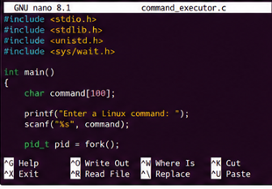

Step 7: Save the File
Press:
Ctrl + O
Press Enter
Then press:
Ctrl + X
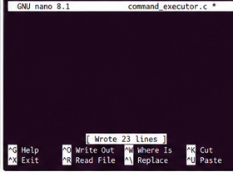

Step 8: Check GCC
gcc --version
If GCC is not installed:
sudo apt update
sudo apt install build-essential -y
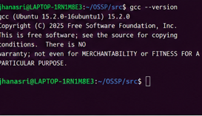

Step 9: Compile the Program
gcc command_executor.c -o command_executor
If there are no errors, the compilation is successful.
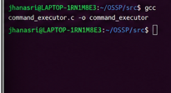

Step 10: Verify the Executable
ls
You should see:
command_executor
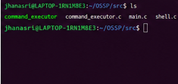

Step 11: Run the Program
./command_executor
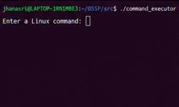

Step 12: Test with ls
When prompted:
Enter a Linux command:
Type:
ls
Example output:
Enter a Linux command: ls

Child Process
Child PID : 1234
Parent PID : 1233
Executing command: ls

command_executor
command_executor.c
main.c
shell.c

Parent Process
Parent PID : 1233
Child PID : 1234
Child process completed.
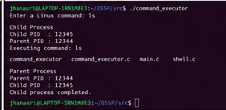

Step 13: Test with pwd
Run again:
./command_executor
Input:
Pwd
-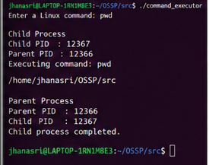

Step 14: Test with date
Run again:
./command_executor
Input:
Date
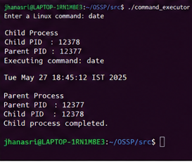

Step 15: Test with whoami
Run again:
./command_executor
Input:
whoami

Step 16: Test with uname
Run again:
./command_executor
Input:
Uname
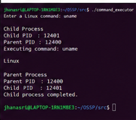
Step 17: Verify the Requirements

Check that your program

Practical Week 2 - Task 2

Step 1: Open Ubuntu
Open Ubuntu from the Start Menu.
You should see:
jhanasri@LAPTOP-1RN1M8E3:~$

Step 2: Go to Home Directory
cd ~
Check:
pwd
Expected:
/home/jhanasri
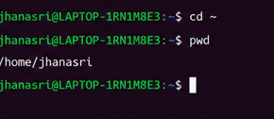

Step 3: Display Linux Kernel Information
Run:
uname
Example Output:
Linux
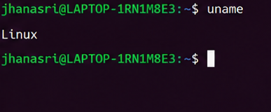

Step 4: Display Complete System Information
Run:
uname -a
Example Output:
Linux LAPTOP-1RN1M8E3 6.18.33.2-microsoft-standard-WSL2 x86_64 GNU/Linux
Take a screenshot.
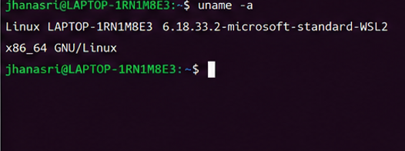

Step 5: Display CPU Information
Run:
lscpu
Example Output:
Architecture: x86_64
CPU(s): 8
Vendor ID: GenuineIntel
Model name: Intel(R) Core(TM)
Take a screenshot.
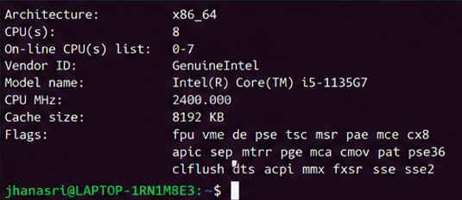

Step 6: Display Running Processes
Run:
ps
Example Output:
PID TTY TIME CMD
1023 pts/0 00:00:00 bash
1050 pts/0 00:00:00 ps
Take a screenshot.
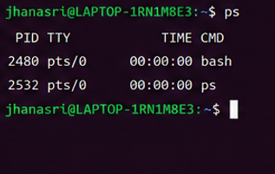

Step 7: Display Detailed Running Processes
Run:
ps -ef
Example Output:
UID PID PPID C STIME TTY TIME CMD
root 1 0 0 10:00 ? 00:00:00 init
user 1050 1023 0 10:10 pts/0 00:00:00 bash
Take a screenshot.
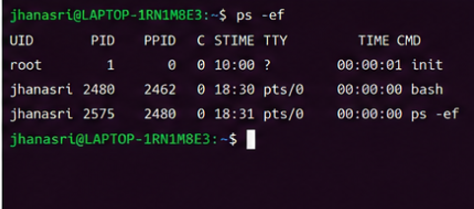

Step 8: Display Live System Processes
Run:
top
Example Screen:
top - 18:45:10

Tasks: 120 total

CPU: 5%

Memory: 22%
Take a screenshot.
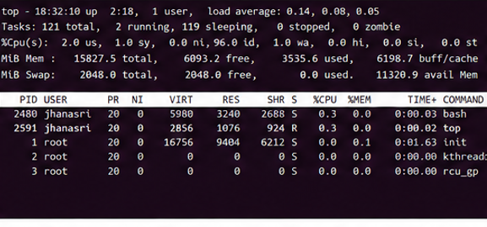

Step 9: Exit Top
Press
Q
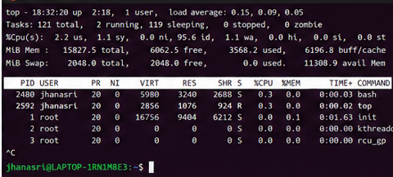

Step 10: CPU Abstraction
Write in your record:
The operating system manages CPU time by scheduling different processes so that each program gets a fair share of processor time.

Step 11: Memory Abstraction
Write:
The operating system allocates memory to each process and protects one process from accessing another process's memory.

Step 12: Storage Abstraction
Write:
The operating system manages files and directories and provides a file system for storing and retrieving data.

Step 13: I/O Device Abstraction
Write:
The operating system communicates with hardware devices such as the keyboard, mouse, monitor, printer, and storage devices through device drivers.

Step 14: Observation
Write:
The Linux commands successfully displayed kernel information, CPU details, running processes, and live system resource usage. The operating system abstracts hardware resources and provides services to user applications.

Step 15: Result
Write:
The Linux terminal commands uname, lscpu, ps, and top were executed successfully. The relationship between hardware resources and operating system services was studied, and the abstraction of CPU, memory, storage, and I/O devices was understood.

